1. All matter is made up of very small particles called _________.
2. Atoms are made up of even smaller particles called ______________________________.
3. Label the Protons, Neutrons, and Electrons in the diagram below.
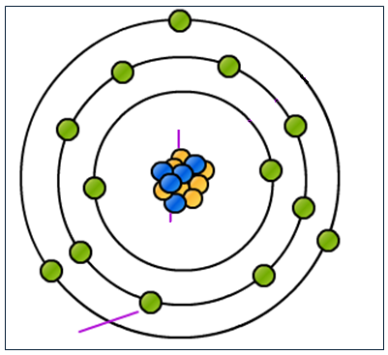

4. Protons and Electrons are ________________________, but ________________ are not.
5. ______________ is a physical property and can be _______________ or _____________.
6. ______________ objects exert a _____________________________________________.
7. Objects that have the same charge ___________________________________________.
8. Objects that have opposite charges ___________________________________________.
9. Draw three pictures demonstrating how charges exert forces on each other. Label the charges and whether the forces “attract” or “repel”

10. Protons have a _____________ charge while electrons have a _______________ charge.
11. Why do electrons stay around the nucleus of an atom? ___________________________
12. The force between charged objects is ________________________________________.
13. Identify two factors that increase the electric force between objects. _________________
__________________________________________________________________________
14. Charged things have _____________________________________________________.
15. Draw the electric field surrounding the “attracted” objects and the “repelled” objects below.

16. Label the electric charge, electric force, and the electric field in the diagram below.
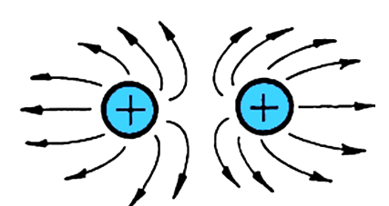

17. Define electricity. ___________________________________________________________
____________________________________________________________________________

18. How does an object become positively charged? __________________________________
____________________________________________________________________________

19. How does an object become negatively charged? _________________________________
____________________________________________________________________________

20. Objects can become charged in three main ways. Briefly describe each method below:
a. Objects can be charged when ____________________________________________
______________________________________________________________________.
b. Objects can be charged when ____________________________________________
______________________________________________________________________.
c. Objects can be charged when ____________________________________________
______________________________________________________________________.

21. Define static electricity. ______________________________________________________
____________________________________________________________________________

22. Describe an example of static electricity “building” up on an object. ____________________
____________________________________________________________________________

23. Describe an example of static electricity being released or “discharged”. ________________
____________________________________________________________________________

24. Define and identify examples of Electrical Conductors. ______________________________
____________________________________________________________________________

25. Define and identify examples of Electrical Insulators. _______________________________
____________________________________________________________________________

26. Explain why many electric conductors are surrounded by electric insulators. Provide an example. ____________________________________________________________________
____________________________________________________________________________

